JAVA PROJECT REPORT

BOULDER DASH

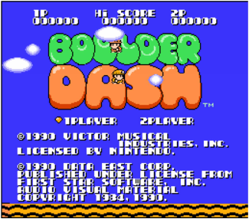

*Caron Alexis – Descamps* Anthony *– Fritsch Florian – Libessart Dimitri*

Contents

Context Analysis: 3

Objectives: 3

Requirement of the Project: 3

UML Language: 3

Package Diagram 3

Component Diagram 4

Sequence Diagram 5

Class Diagram 5

Planning 10

Projected Planning: 10

# Context Analysis:

## Objectives:

* Design 5 levels of the game Boulder Dash.
* Write the code of the game with the Java language.
* Use a Database to load the sprites of the game.

## Requirement of the Project:

* Use the UML language.
* Create a Package Diagram, a Component Diagram, a Sequence Diagram and five Class Diagrams.
* Create several Junit tests and create a SureFire Report.

### UML Language:

For the project, we had to draw several diagrams. All of them had to respect the UML language.

## Package Diagram

The Package Diagram is a diagram which describe and represent all the package in the system. In this one, we must draw the package and the sub-package, and the relations between them. The classes and the interfaces don’t must be represented.

This is our Package Diagram:

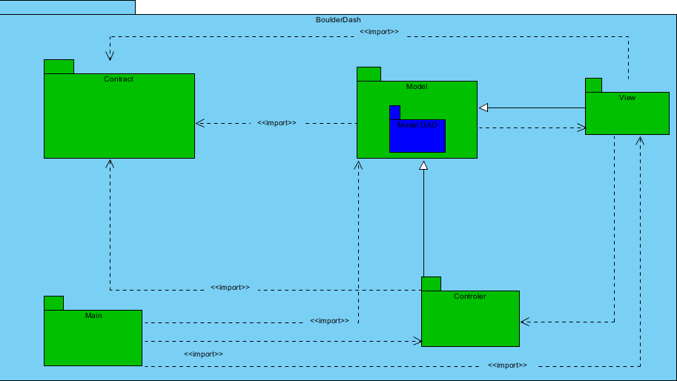

## Component Diagram

The Component Diagram is a diagram which describe how component are wired together. They are used to illustrate the structure of complex systems. A component is represented by a rectangle with either the keyword “component”, and the interfaces are represented by a circle.

This is our Component Diagram:

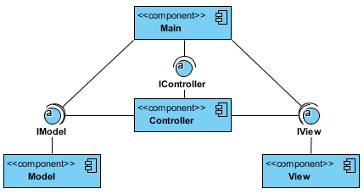

## Sequence Diagram

The sequence Diagram is an interaction diagram that shows how objects operate with one another and in what order. It is a construct of a message sequence chart.  
The objects are represented by a vertical lifeline, and the message which are the actions operated, are represented by horizontal arrows.

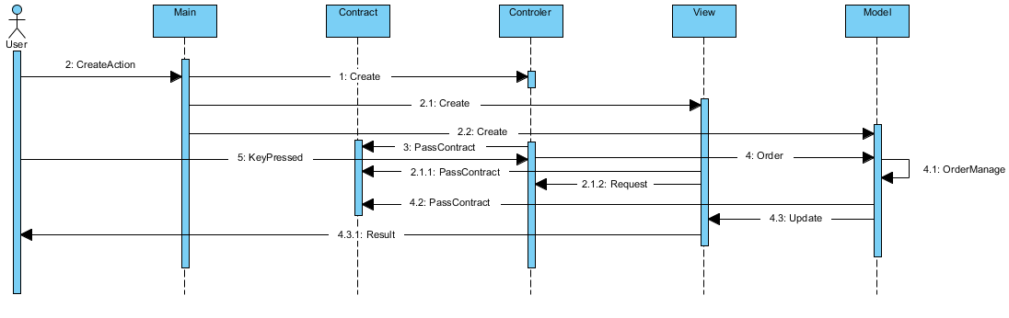This is our Sequence Diagram

## Class Diagram

The Class Diagram is the most important diagram in the UML language, because he’s the most detailed. He describes the structure of a system by showing the system’s classes, and also their attributes, their operations, and their relationship among their objects.

For this project, we must draw five classes diagrams, one per each package.

#### Model Class Diagram

#### Controller Class Diagram

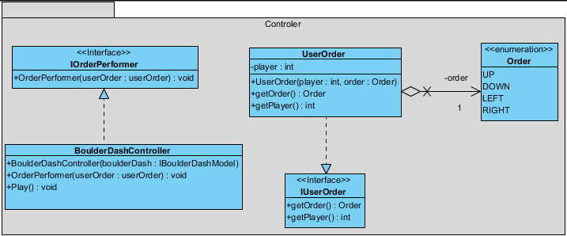

#### View Class Diagram

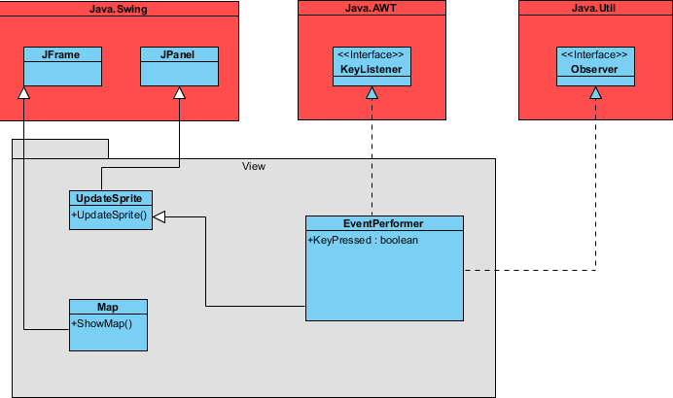

#### Contract Class Diagram

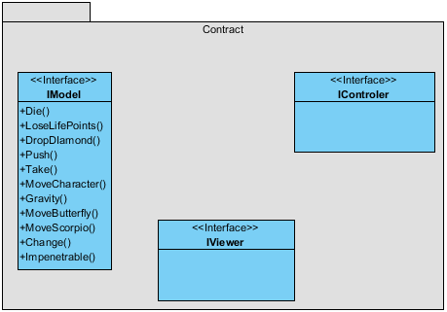

#### Main Class Diagram

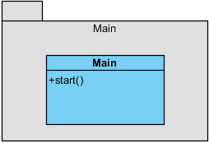

# Planning

## Projected Planning:

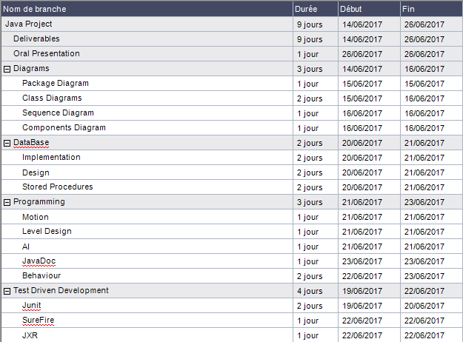

At the beginning of the project, we plan